**Danya Peters**

**Capstone Project Milestone Report**

Introduction to the Problem:

In a comparison of high school graduation rates across the United States for the class of 2011, Nevada ranked the worst among states with a graduation rate of 62%. Over the last five years, much effort has been expended state-wide to increase Nevada’s graduation rates. The current analysis will primarily focus on the students in Washoe County and Clark County School Districts. Washoe County School District (WCSD) is the second biggest school district in Nevada and covers much of Reno, Sparks, Incline Village, and surrounding areas in Northern Nevada. Clark County School District (CCSD) is, by far, the biggest school district in Nevada and covers much of Las Vegas, Henderson, North Las Vegas, Boulder City, Mesquite, and surrounding areas in Southern Nevada. Together, these two school districts represent the largest urban areas of Nevada.

Research Questions:

The current analysis will address the following questions:

1. How have the WCSD and CCSD graduation rates compared to the state of Nevada rates as a whole?
2. What has the trend in graduation rates been over the last five years, both statewide and in WCSD and CCSD?
3. Which groups of students have shown the biggest gains in graduation rates in WCSD and CCSD?
4. Which groups of students have shown the smallest gains in graduation rates in WCSD and CCSD?

Analyses will focus on developing an improvement model that compares successive cohorts of graduating seniors in WCSD and CCSD with the state of Nevada over a five year period. A positive change will represent improvement at the district and state level, while a negative change will represent a lack of improvement. Exploratory plots of the aggregated graduation rates will be used to analyze trends over five cohorts of seniors (classes of 2011-2015).

Data:

Data has been drawn from the Nevada Annual Reports of Accountability, which are released annually by the Nevada Department of Education. Aggregated graduation rates comprise the outcome data, with no individual level results. Data was downloaded from <http://www.nevadareportcard.com/di/main/cohort>.

The data set contains graduation rates for each school in WCSD and CCSD, as well district level graduation rates and state level graduation rates. The data set also contains graduation rates for several special populations in the districts: students who receive free or reduced price lunch (FRL), students on Individualized Education Plans (IEP), and students who are English language learners (ELL).

The data set does not contain any information about changes at the district or state level that could explain trends in the data. As such, legislative efforts to increase graduation rates will be described and unemployment data will be analyzed in order to help explain any trends that are found.

Minimal data cleaning was necessary. Data pulled from the Nevada Annual Reports of Accountability were already organized into “tidy” data. Washoe County School District was referred to as both “WCSD” and “Washoe” in the data set and substitution was used to standardize them to “Washoe”.

Preliminary Data Analysis:

In order to address the first two research questions, graduation rates for the classes of 2011 to 2015 were plotted for both WCSD and CCSD, as well as the State of Nevada as a whole. This plot compares successive cohorts of graduating seniors in WCSD and CCSD with the state of Nevada over a five year period.

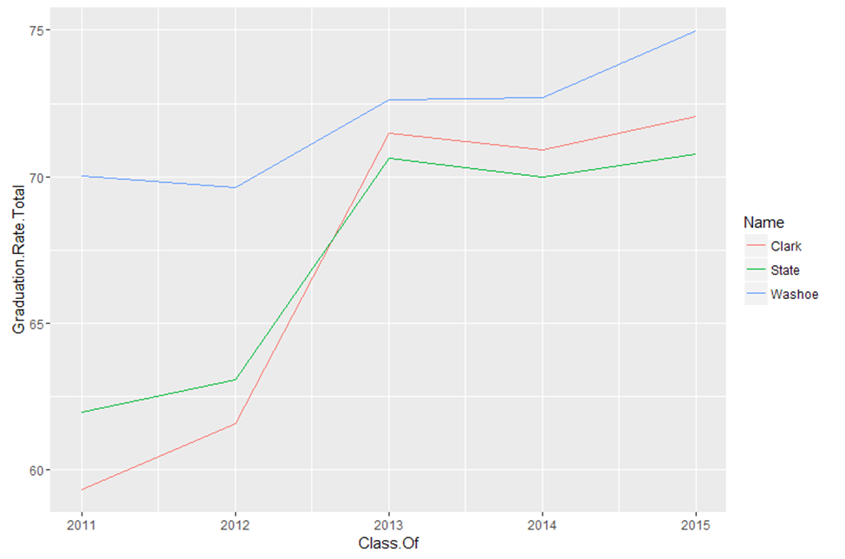

As can be seen in the plot, WCSD has had the highest graduation rates overall when compared to CCSD and the State of Nevada as a whole. The graduation rates for WCSD increased from 70.04% in 2011 to 74.99% by 2015. WCSD rates improved 4.95% between 2011 and 2015. The 2011 graduation rates for CCSD were lower than both the WCSD rates (59.34% vs. 70.04%) and the State of Nevada rates (59.34% vs. 61.96%). However, CCSD graduation rates passed the State level rates by 2013 and continued to be higher through 2015 (72.07% vs. 70.77%). CCSD graduation rates improved 12.73% between 2011 and 2015. These positive changes represent improvement at both the district and the state level.

The next phase of the data analysis included identifying schools who had shown the greatest amount of improvement from 2011 to 2015. The school in WCSD that had shown the greatest amount of improvement for this five year period was Hug High School. Between 2011 and 2015, the graduation rates at Hug High School improved 26.10%. In order to assess whether similar schools in the CCSD had shown similar rates of improvement, data from the National Center for Education Statistics was used to match Hug High School with similar schools in CCSD. Matching was based on Title 1 status, total number of students, student/teacher ratio, gender, and race/ethnicity. Eldorado High School was shown to be the best match for Hug High School. However, Rancho High School was also very similar (with the exception that it has more than twice as many students).

                                        Hug                   Eldorado               Rancho   
Title 1 School                  Yes                   Yes                       Yes   
Total Students                 1351                 1823                      3166   
Student/teacher ratio       20.63                23.08                     23.8   
%Hispanic                       70                     70                          70   
%Nonwhite                      86                     87                          89   
%Black                            6.5                    12                          9   
%male                             52.7                  53.7                       52

A second plot was created that compared the graduation rates for Hug High School, Eldorado High School, and Rancho High School. This plot compares successive cohorts of graduating seniors from these high schools over a five year period.

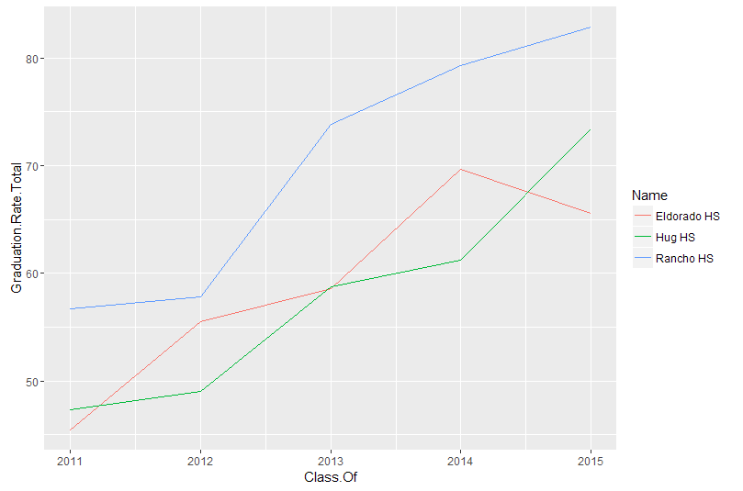

As can be seen in the plot, all three high schools showed huge increases in graduation rates from 2011 to 2015. Over this five year period, Hug High School graduation rates improved 26.10%, Eldorado High School graduation rates improved 20.09%, and Rancho High School graduation rates improved 26.16%. The overall trend is one of improvement for all three schools, although Eldorado had its highest graduation rates in 2014.

Future Analyses:

It is interesting to note that both of these plots show similar improvements over time, with a spike in 2013 for most data points. Legislative efforts to increase graduation rates will be described and unemployment data will be analyzed in order to help explain these trends.

Graduation rates for Special Populations will also be analyzed to assess any trends in the data. Results from these analysis will provide WCSD and CCSD with information about the groups of students whom they can focus on to continue to improve their overall graduation rates. Those groups of students who have shown the least gains over the last five years represent the biggest opportunities for improvements in the future.